WRIST FRACTURE - ADVICE FOR WHILE IN CAST
- While in cast, make sure you keep exercising your shoulder, elbow & hand regularly. This is important to prevent stiffness in unaffected joints and will help in regaining your function once your cast is removed. Exercises are shown below.
- Swelling management is important to ensure a well-fitting cast and to allow full movement in your fingers/thumb. To help manage swelling:
- Raise your arm above your heart when resting.
- Keep the unaffected joints moving normally.
- It is important to continue with light functional tasks while you are in cast e.g. you should be able to touch your thumb to your fingertips to allow you to do up zips/buttons.
- You should not be driving or doing any heavy lifting while in cast.
- There is also a YouTube video which you can follow. You should search on YouTube ‘NHS Grampian wrist fracture’ (https://www.youtube.com/watch?v=HEWtDZPjO7c)
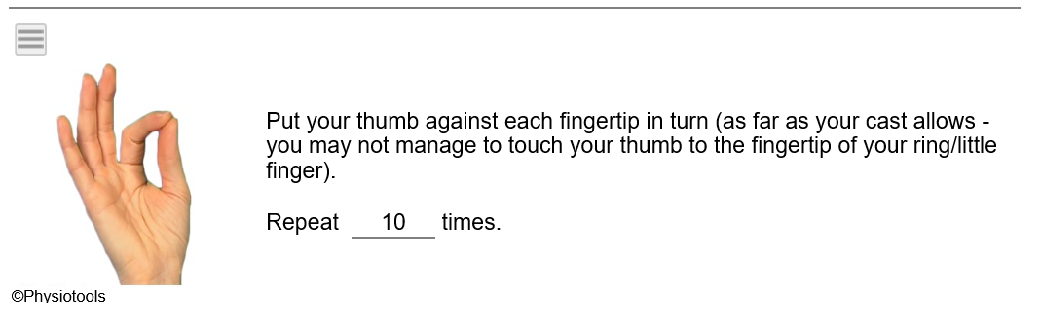
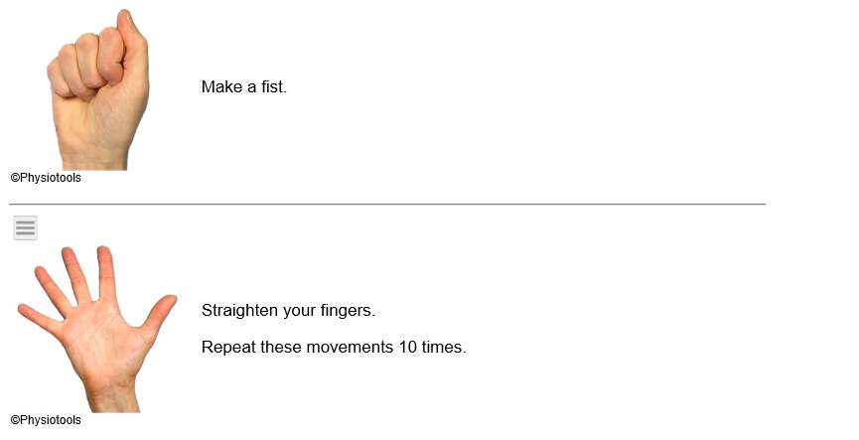
The following exercises should be done hourly during the day:

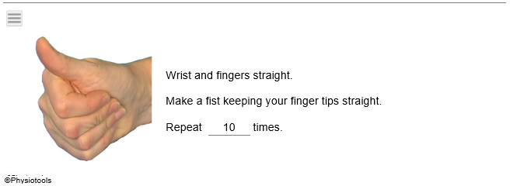
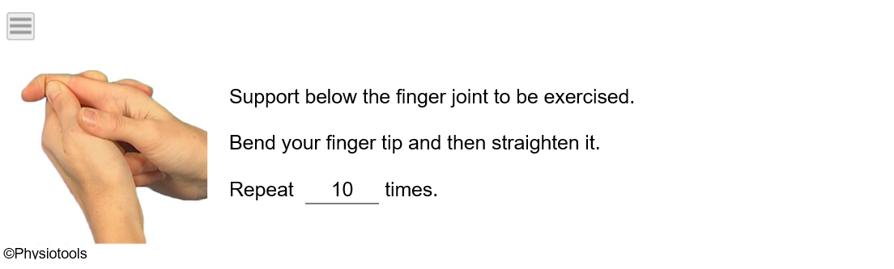
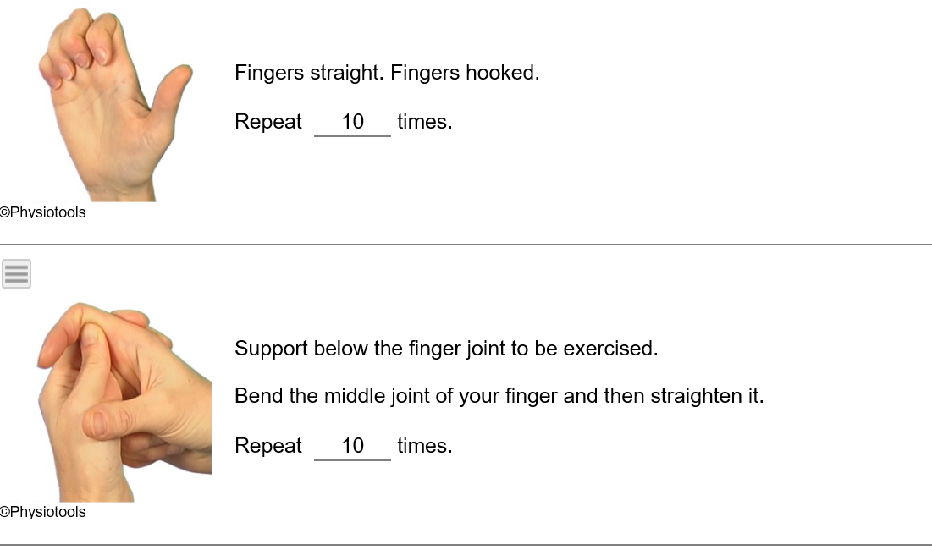

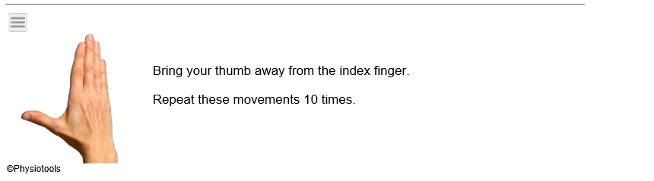
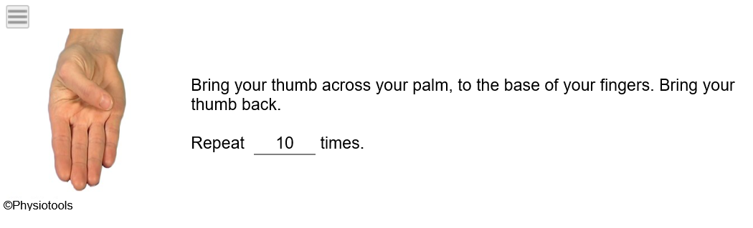
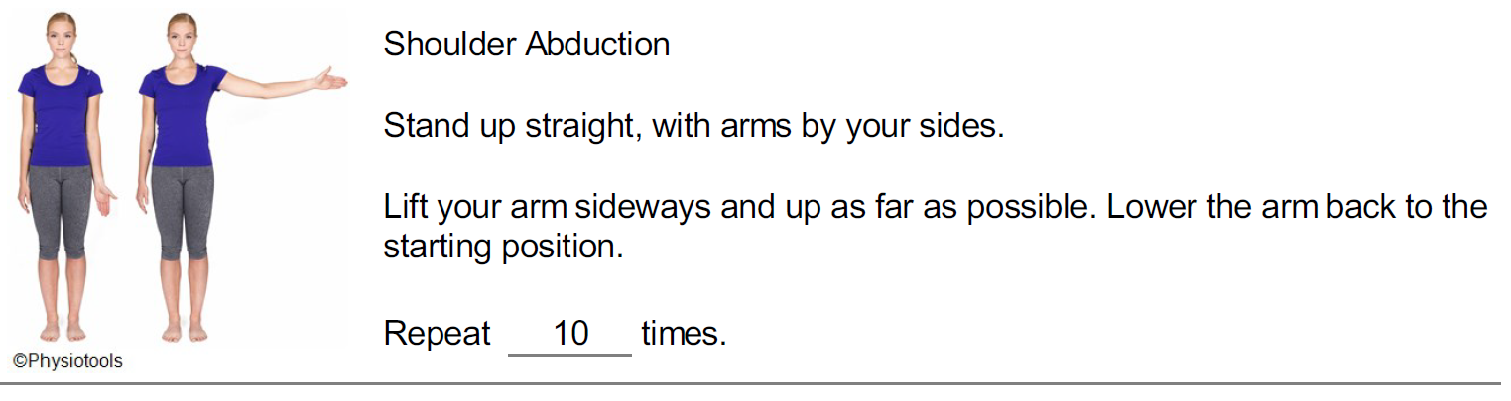
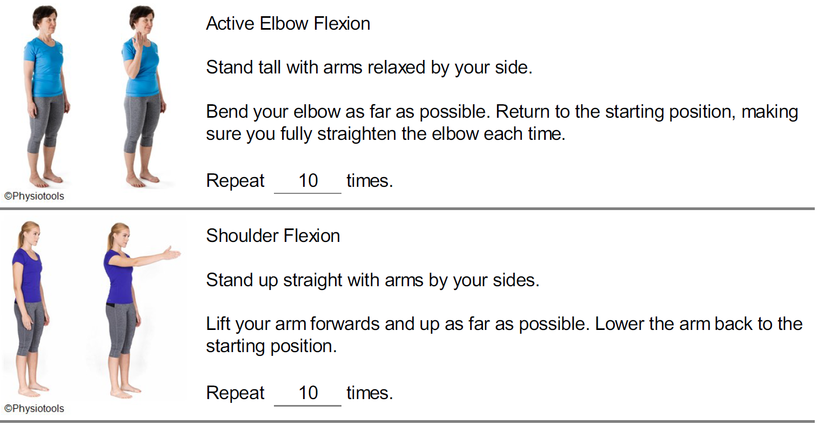
The following exercises should be done 3 - 4 x daily:

